

217, Sheikh Rashid Building

P.O Box 56272, Dubai

United Arab Emirates

Tel: +971 4 2973236 / 04 2974007

Email: uae@verbat.com

PROJECT   
PROPOSAL

**Memo Printing**

|  |  |
| --- | --- |
| **Prepared for:**  **????** | **Submission Date:**  01 Sept 2017  **Proposal ID:** AD/BP/01092017/1343/1 |

___________________________________________________________________________________________________________________________________________  
Conﬁdentiality Notice: This Proposal is conﬁdential and contains proprietary information and intellectual property of Verbanet Technologies LLC. Neither this proposal nor any of the information contained herein may be reproduced or disclosed under any circumstances without the express written permission of Verbanet.

© 2017 by Verbanet Technologies LLC. All rights reserved. Confidential.

___________________________________________________________________________________________________________________________________________

Project Contacts

|  |  |
| --- | --- |
| Client Information | |
| Project Name |  |
| Client Name |  |
| Client Address |  |
| Contact Person |  |
| Contact Person Email |  |
| Contact Person Phone Number |  |
| Verbat Information | |
| Contact Person | Joyce Daniel |
| Contact Person Phone Number | +971 42973236 |
| Contact Person E-Mail | joyce.daniel@verbat.com |
| Address | PO Box 56272, Dubai, United Arab Emirates |
| Physical Address | 217, Sheikh Rasheed Building, Hor Al Anz East |
| Project Information | |
| Proposed Technology/Methodology | PHP / MySql / ICONIC or PhoneGAP / HTML5 |
| Anticipate Start Date | NA |
| Proposal Valid For | 30 Calendar days from the submission of the proposal |

**Table of Content**

1 Executive Summary 4

1.1 Proposed Solution Model 5

1.2 Solution Objective 5

1.3 Advantages of Proposed Solution 6

1.4 Why Verbat 7

1.5 Key Differentiators 8

1.6 Technology & Services 9

2 Functional Specification 10

3 Non Functional Requirements 10

4 Assumptions 11

5 Out of Scope 11

6 Technology Solution 12

6.1 Proposed System Environment 12

6.2 Technical Configurations 13

6.2.1 Development Tools 13

6.2.2 Recommended Web Hosting Package 13

6.2.3 Browser Compatibility 13

6.2.4 Hardware Interface 13

7 Commercials 14

7.1 Web Application 14

7.2 Payment Terms 14

7.3 Mode of Payment 14

8 Delivery Management 15

8.1 Project Management 15

8.2 Roles and Responsibilities 15

8.3 Delivery Activity Summary 17

8.4 Project Implementation Plan 17

8.5 Deliverables 17

8.6 Estimated Delivery Time 18

8.7 Deployment Details (at Clients Behest) 18

8.8 Release Planning 18

8.9 Risk and Contingency Planning 18

9 Change Management 19

10 Miscellaneous 21

10.1 Acceptance Criteria 21

10.2 General Terms and Conditions 21

10.3 Assumptions and Dependencies 22

10.4 Source Code & Intellectual Property Rights 23

10.5 Maintenance & Support 23

10.6 Service Level Agreement 24

11 Our Clients 25

# Executive Summary

Write something about the client

## Proposed Solution Model

**Stand-Alone Fixed Bid**

Verbat will be following a stand–alone fixed bid solution delivery model wherein the required solution would be devised and a suitable pricing would be offered.

## Solution Objective

The client requires an application that will fulfill the following requirements

* Ability to design and save our templates with movable controls.
* Different templates with different fields with the ability to design them separately.
* Report showing all past printed memos.
* A settings page to set font, font size, printer and other relevant settings
* The following pages will be included in the solution
  + Design template: Ability to choose a template and design it by moving or re adjusting controls on it. (*Deferred for implementation at a later stage*)
  + Print page: Select a template, which shall allow the static fields in the memo to be populated
  + Bulk printing: Ability to print bulk memo using a CSV upload file.
  + Reports: Report to show all history memo’s (cash and cheque deposit) printed with filters on dates, user and reference number
  + User Management: User Management module to create/edit/delete users of the system
  + Settings Page: Set Font, Font size, printer selection and other settings.

Verbat’s Solution architects have conducted a thorough research on the requirements and have come to the conclusion that our proposed solution, which is detailed further in this document, will meet the requirements put forth by the client. And the proposed solution will be delivered in a phased approach as per Verbats stand-alone fixed bid solution model.

**Strong and Scalable platform:** The platform proposed will be strong and scalable enough to accommodate future enhancements.

**Accelerated solution:** The framework would act as a solution accelerator. It would provide the basic building blocks which could be reused in future for building new components and features.

**High performance:** The light weight framework used consumes fewer system resources thereby making the application perform faster.

**Security:** The application will be developed considering various aspects of security.

## Advantages of Proposed Solution

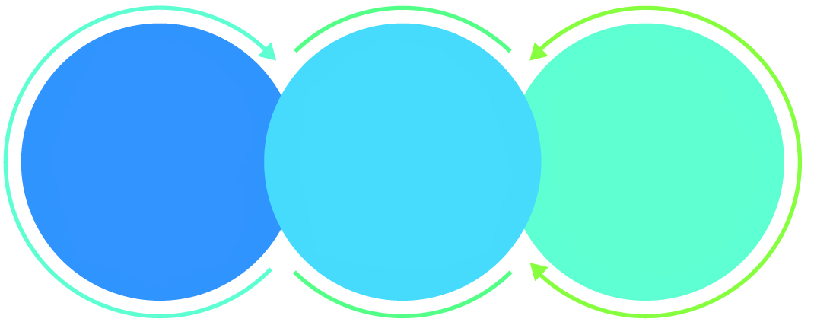

01

Agile development offering reliable, secure solution

02

Smooth transition and quicker completion of processes

03

User friendly interfaces enabling easy navigation between screens

## Why Verbat

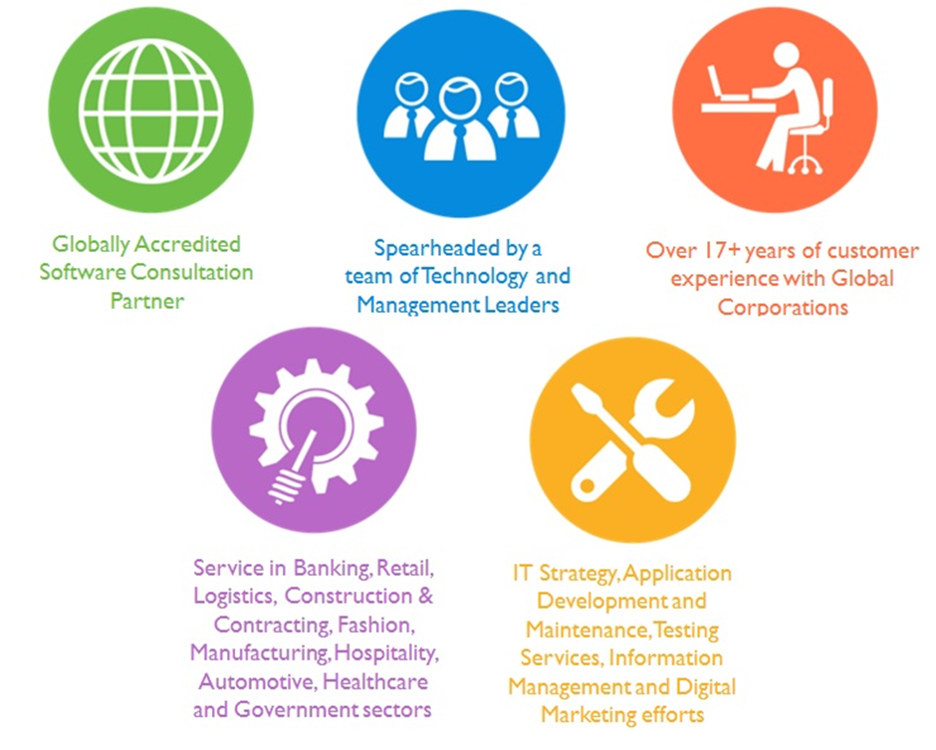

## Key Differentiators

Delivered digital transformation expertise to global customers for over a decade by following industry best practices to maximize ROI for client

Keen technology intelligence combined with aggressive market research to deliver solutions that achieve results with measurable value

Enable access to global consulting expertise with strong local market and business knowledge

Commercial Model that is customizable for your business needs

Services that are designed to optimize applications for improved performance and overall efficiency

1,000,000 plus man-hours of expertise in technology frameworks spanning Microsoft, Open Source, mobility platforms and other proprietary IT technology

Partners top technology vendors to bring in the latest and best services in integration, collaboration, and development

Commercial Model that is customizable for your business needs

Proven Methodologies & Processes

Investment in R & D

Strong Local Presence

Flexible commercial Models

Technology Associations

Software Development Experience

Offshore Development Centre

Quality Assurance & Testing

## Technology & Services

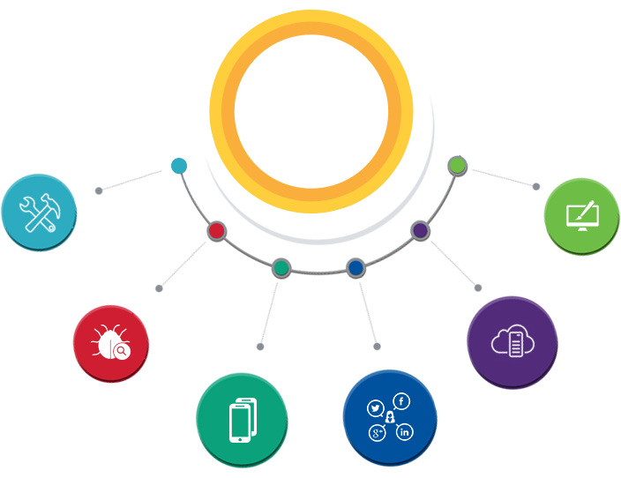

Technology  
&  
Services

Cloud/Traditional Hosting

User Interface & Design

Digital Marketing

Mobility Solutions

Testing Services

Application  
Development

# Functional Specification

The main features of the application to be developed are

|  |
| --- |
| **Design** |
| Create prototype of the website (except print layout) |
| Conduct meetings to discuss and finalize the prototype |
| **Development and Production** |
| Set up development environment and server - PHP |
| Dashboard |
| Manage Customers |
| Manage Memo Print |
| Check Deposit :: Design print layout compatible to dot matrix printer |
| Check Deposit :: Manage Memo printing data |
| Cash Deposit :: Design print layout compatible to dot matrix printer |
| Cash Deposit :: Manage Memo printing data |
| CSV upload :: Check Deposit |
| **Testing and training** |
| Test for full functionality on all major and active browsers |

# Non Functional Requirements

|  |  |
| --- | --- |
| **Requirement** | **Details** |
| User Experience and  UI Design | * The application will be developed only in English (If Arabic is required we can accommodate the same on the website. Note that internationalization is not supported in Zoom) * The layout and graphical components will be created considering the usability factors |
| Performance | * Application will allow users to have smooth and quick access to the information or services they require. |
| Security | * The system will be protected against attempts of security breaching that may arise. * Web security standards will be followed. |

# Assumptions

The project solution and technology is created from the initial understanding of the requirement shared with Verbat through mails and meetings. The proposed solution is based on the following assumptions:

* Client to provide Verbat with the branding guidelines.
* The proposed application front end and backend would be developed in English.
* Client will purchase the necessary templates needed for development
* Client shall provide licensed images and logos in specified size & format
* Super Admin can manage all the users within the application.
* Requirements should be well defined, agreed and signed-off by the client
* Internet connectivity is required for the functioning of the web/mobile application.

# Out of Scope

With the ever evolving digital market, the requirement needs should be clear to both the parties involved, hence the importance of mentioning the out of scope details of the project. Following are considered to be out of scope while creating this proposal.

* Purchase of images, fonts
* Adding new features to the application other than mentioned in the functional specification.
* Any language other than English & Arabic
* Manual data entry
* Hardware Integrations / procurement and purchase
* Database migration
* Content writing
* Content or image procurement or uploading or editing.
* Hosting Infrastructure and Maintenance
* Annual Maintenance of the application (Bug fixing, debugging) - For AMC details, please refer section titled “Maintenance and Support”
* Physical deployment at client’s site
* Backup solution and Disaster recovery

# Technology Solution

## Proposed System Environment

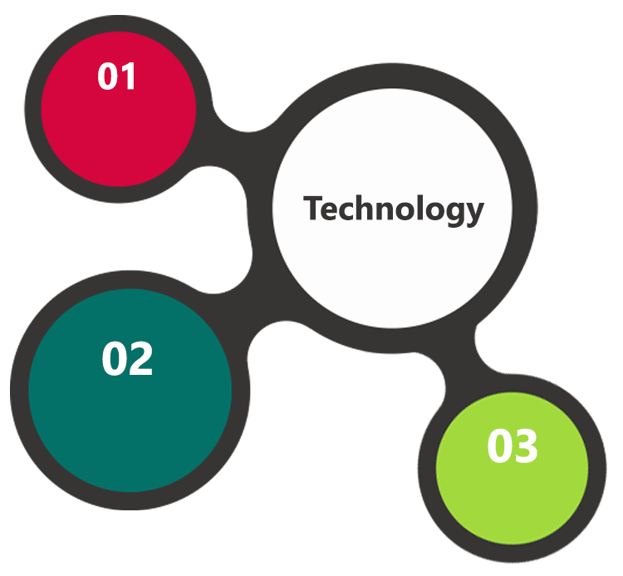

PHP, Code Igniter, MVC

HTML / CSS3

Linux OS  
 Apache  
 My SQL

**MS SQL2012  
Windows 8/10  
Web Services**

## Technical Configurations

### Development Tools

* PHP, Code Igniter
* My SQL
* HTML / CSS 3
* Web services, Ajax, JavaScript

### Recommended Web Hosting Package

* Medium CPU power – single to dual CPU
* Single Domain
* Windows/Linux OS
* Disk Space: 5 GB
* Monthly Bandwidth: 10 GB
* Control panels e.g. cPanel-v_11.42
* Web site Server Software – Apache
* PHP 5 Framework

Clients can also host using Amazon Web Services.

### Browser Compatibility

* Chrome version: 56
* Firefox version: 51
* Edge version: 39

### Hardware Interface

**Desktop**

The application is reliant on hardware interfaces to provide a seamless automated user experience.

* Computer with Windows 8 or 10 OS
* Compatible Browsers as specified in section 7.2.3

**IOS System Requirements**

iPhone 4+

iPad 4 +

OS 7 +

4G/LTE

40 MB Free Space

**Android Device Specifications**

1 GB Ram

ARM processor

Android 4+ and above

high-speed Wi-Fi and 4G LTE networks

40 MB Free Space

# Commercials

## Web Application

|  |  |  |
| --- | --- | --- |
| **No** | **Description** | **Amount (USD)** |
| 01. | Responsive web app | 00,000.00 |
|  |  |  |

## Payment Terms

* Payment terms

*Note: Payment should be made within 7 days from the date of the invoice*

## Mode of Payment

By Cheque / DD to Verbanet Technologies LLC

OR

Wire transfer to our bank account

Bank Name : Emirates NBD

Account Name : Verbanet Technologies LLC

Account Number : 1011492858201

IBAN Number : AE61 0260 0010 1149 2858 201

Swift Code : EBILAEAD

Bank Address : Mamzar Branch, Dubai

*Note: Bank charges incurred during wire transfer to be borne by the client. Any local taxes applicable to be borne by the client*

# Delivery Management

## Project Management

The Verbat development center strictly follows industry standards on quality. The project management is process governed by the Verbat Quality Management system and is put to verification through internal audit programs that happen from time to time.

Verbat will dedicate a project manager for the proposed implementation. Verbat proposes Client to identify one project manager who will be driving activities to be undertaken by Client to be the single point of contact for Verbat.

## Roles and Responsibilities

Verbat will assign a dedicated Project Manager/Project Lead to lead the project, who will be the first point contact for Client. He/she will be responsible for planning and managing the various activities within the project. He/she will work closely with Client Project Manager, to give periodic status updates and ensure high level of visibility and comfort on the progress of the project.

The Project Manager/Project Lead will lead the co-ordination between Verbat and Client, thus enabling smooth transitioning of Client requirements to the Verbat’s offshore delivery team, and provide visibility as well as comfort on the progress of the services to Client.

He/she will have periodic meetings with Verbat’s Senior Management, thus ensuring Verbat’s Management commitment and focus on Client initiatives.

## Delivery Activity Summary

|  |  |
| --- | --- |
| Activities | Description |
| Detailed requirement Analysis | Verbat team to conduct detailed study of requirement for the phase. If clarification is required, team will reach out to Client for more information and/or time for discussions. |
| DB Design | DB design for central and test DB. |
| Software Requirement Specification document (SRS) | Once the requirement analysis is completed, Verbat team will submit the SRS document for approval |
| UI/UX Design, Prototyping | Based on the SRS, Verbat UX/UI team will work on the UI/UX of the screens and submit a prototype for approval |
| Functional Specification Document (FS) | Once the Prototype. UI/UX is approved, Verbat shall submit an FS document for approval. |
| Development | Actual system development starts based on the FS. This involves detailed design and software development of Web Application. |
| Testing | Test Planning, test plan creations, internal, integration testing and user acceptance testing. |
| Deployment | Deploying the latest built in the Verbat Test Server. |

## Project Implementation Plan

Verbat will be providing the solution in a stand-alone fixed bid approach which ensures minimum viable solution for quick wins with core focus on the long-term business objective and outcome. Once the implementation is over, Verbat will initiate the application maintenance process (once the maintenance contract is signed) which continues to extend after the implementation.

## Deliverables

* Software Requirement Specification Document (SRS)
* Prototype of the application
* Functional Specification Document (FS)
* Fully Developed & Tested Application

## Estimated Delivery Time

The effort estimated for delivering the application will be as below:

**UAE working days for prototype from the date of Approval of the project (LPO/Signed proposal) with advance payment: 7 days**

**UAE Working days for the development of the application from the Date of Approval of the Prototype: 22 days**

| **Activity** | **Deliverables** | **Timeline** |
| --- | --- | --- |
| Project Initiation | SRS, Functional Specification,  Working Prototype | Week 1 |
| Development |  | Week 4 |
| Deployment | Tested Web & Hybrid App | Week 5 |

## Deployment Details (at Clients Behest)

* Client can opt for hosting the application at Verbat’s Server.
* If deployment is at the client’s server, responsibility of deploying the application onto the production environment after conducting the necessary acceptance testing will lie with the client unless and until Verbat’s support is contracted for deployment.

***Note****: Hosting the application at Verbat’s server will call in for additional charges.*

## Release Planning

* Client will be informed about the release date and time through email.
* Client performs the UAT

## Risk and Contingency Planning

Verbat has identified various risk factors associated with this assignment and understands the impact of these risk factors on the project schedules. The objective of this section is to highlight for both Verbat and client, the risk factors, to analyze the impact of the risks on project execution, and to propose strategies to control and reduce the impact of the risk factor.

These various risks, which could arise during the project, are tabulated below along with mitigation implementation.

| Type of risk | Impact | Risk Mitigation | Risk Handling |
| --- | --- | --- | --- |
| Scope Creep | H | Functions and features will be detailed in system requirement documents and will go through client approval. Once this document is approved, any change to requirement will go through change management review for possible impact assessment. | Proper change management procedure will be implemented. |
| Delay in customer feedback | H | The plan is prepared with enough lead-time for customer reviews and approvals.  The customer is indicated with the dates when the document is expected after review and approval. | The request for feedback will be escalated if not attended at the right time so that the schedules are not affected. Deemed acceptance criterion is set up front and will be followed. |
| Non-availability of necessary software’s, frameworks, database instances and infrastructure at client’s hosting environment(If hosting support is provided by Verbat) | M | Client will be informed in advance on these requirements. | Possible impact to schedule. |
| Manpower attrition | L | All efforts would be made to ensure process dependence rather than being person dependent. As a risk mitigation plan Verbat will train backups. | A new person will be identified as early as possible, provided the required project-specific training and mentored by the senior members of the team to minimise impact of attrition on the project. |

*H-High, M-Medium, L-Low, NA-Not Applicable*

# Change Management

Any addition which comes out of the project scope, upon and after the launch of the tool will be considered as change management. Verbat recommends the following change management procedure for the same.

* Any change which comes out of the project scope, which was discussed, documented, and mutually approved by both the parties in the requirement stage, will be carried out only through raising a change request.
* Change request will be studied and an impact analysis on the existing work flow will be performed.
* On finalizing the impact, effort estimation for the change will be calculated and raised as additional requirement.
* Verbat will initiate the change request only after getting a formal approval from the client for the additional changes raised.
* Any change from the scope will be charged at **USD ----- per man day effort** and approval from the clients will be availed before commencing on any change management.

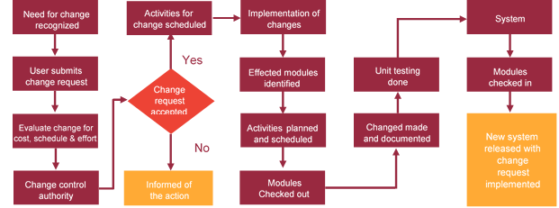

# Miscellaneous

## Acceptance Criteria

* UAT sign off should happen within 7 Days from the release of the application/ Phase and the acceptance confirmation needs to be mailed to Verbat failing which Verbat will consider the project as approved by the client.
* Any comments or reason for rejection need to be documented and the same needs to be sent as an email from the official mail id of client to Verbat.

## General Terms and Conditions

* An average of 20 working days are assumed in a month
* All the projects activities will be carried out from our off-shore development center in India
* The scope of the project is to develop the Application as detailed in the scope of the project and mentioned in this proposal. Any changes or additions will have to go through change management.
* This proposal and all technical/ functional specifications have been derived or concluded from the data shared via email / information's transferred during the initial requirement analysis meetings and conversations. Verbat reserves the right to amend the terms of this proposal, should the SOW terms, functional features and functionalities change during the course of the project
* Application will be best viewed only in the environment mentioned in the section 7.2.3
* All the documentation will be provided in English.
* Third party components may be used to develop this application.
* All Source Code and other project artefacts would adhere to the Verbat document templates and internal coding standards
* Acceptance criteria shall be based on the clauses which were mutually discussed between Verbat and client at the Requirement Analysis phase and the same will be documented and approved by both parties through official emails
* In case Client requires any extension of the proposed acceptance schedule, the associated effort and cost of such extension can be mutually reviewed.
* For any circumstances if project needs to be put on Hold / Stop it requires minimum request notice period of 1 week along with duration for which request will be addressed by management and final decision on the request will be based on that
* If deployment is done in client’s server, Verbat cannot be held responsible for any performance issues arising due to hardware malfunctions.
* Client is responsible for data backup in case the application is not hosted on Verbat server.
* Source code will only be delivered or uploaded on the Production Server once the due payments are made.

## Assumptions and Dependencies

* Detailed system study is required before the start of the project.
* During the requirement gathering phase, authorized personnel from the Client’s side is expected to be available for discussion and finalizing the HLD (High Level Design), before development commences.
* Type of reports and formats, if under the scope of the project, needs to be specified by Client before project sign off.
* Workflows if under the scope of the project, need to be specified/ confirmed by client before project signoff.
* All queries regarding the client requirement and any queries which may hinder the project advancement at any stage should be answered by the client within 24 hours from the time of initiation, failing which the time delay will get added to the actual effort which was estimated.
* Verbat assumes that all sign-offs from Client will be provided within agreed and specified timeframe.
* Client will provide all the necessary contents, both text and image, before starting the project in the format suggested by Verbat (if any).
* The client should provide the relevant information and data well in time for the execution of a related activity. Non- availability of this information or data may lead to an interruption of work which may result in a delay in delivery as well as additional costs to the client.
* Client should have/possess server with technical specifications as suggested by Verbat for the proposed application.

## Source Code & Intellectual Property Rights

* Upon completion of the Project and 100% completion of the payment, client will have access to the source code except for propriety codes, developer tools and third party application etc.
* The solution offered will be the intellectual property of the client and will be made available to the client on an “unlimited license” basis.
* Modifications by third party/person: No person or organization, other than Verbat or any person authorized by Verbat in writing, has any permission to modify/change the software Solution to be eligible to get continued support from Verbat as per the support terms defined under this document.
* Liabilities/Damages: Verbat accepts no liability or damages of any kind arising out of use or non-use of the software delivered. The responsibility of testing of software lies with Client.

## Maintenance & Support

* Maintenance contracts by default are supported as per the basic SLA terms.
* **AMC with Basic SLA is charged at 20 % of the total project value**. Additional Effort/change management request will be added towards Total Value of the Project to determine the AMC value.
* Maintenance support is limited to providing application support for ensuring the consistency of the look-and-feel, bug fixes and user issues i.e. maintenance and support of the existing features of the application.
* Support does not in any way cover providing technical or other support to the end users. The maintenance agreement does not include functionality changes or feature additions which are handled as change requests which will be charged AED 1200 per man day. AMC does not include server support, maintenance and application deployment.
* AMC charges will cover Off-Site Support and Debugging. Support includes E-mail, Telephone and Chat unless explicitly specified. In the event, the application is hosted with the client; necessary remote desktop connectivity should be provided for carrying out maintenance activity.
* Gap in AMC - In case if the client does not opt an AMC for a year and want to renew it after that period, 50% of the AMC amount for the year for which AMC is not taken will also be payable if the client wishes to renew the AMC contract.
* Note:
  + Please note that the AMC support shall start only after all the necessary sign-offs (AMC Document) to this effect have been given.
  + It is not mandatory that the client should opt for an AMC. The client will still be supported on an ad-hoc basis on an agreed man-day rate.
  + AMC Payment Terms: 100% to be paid as advance.

## Service Level Agreement

|  |  |  |  |  |
| --- | --- | --- | --- | --- |
| **Key** | **Max Response Time** | | **Max Resolution Time** | **Target** |
| Basic | 1  working day | 3 working days | | Request / incident / problem tickets |
| Advanced | 5 Business Hours | 12 Business Hours | | Request / incident / problem tickets |
| Priority | 3 Business Hours | 5 Business Hours | | Request / incident / problem tickets |

Note:-

* We provide Basic SLA as standard with AMC while Advanced and Priority SLAs attract additional charges.
* Time zone applicable as per India time zones (3:30 AM GMT to 12:30 PM GMT- Monday to Friday).

# Our Clients

**UAE University**

Education

Transportation

**Canada Cartage**

Construction

Services

Finance

We look forward to hearing from you soon and hope that you will give us the privilege to work with you in meeting your business goals. Thank you.

Thank You



©   
1999 - 2017. All Rights Reserved   
Verbanet Technologies LLC  
www.verbat.com